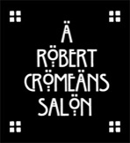
Freelance Opportunity

A Robert Cromeans Salon is a HYBRID salon
that has employees and freelancers working side by side.

Enjoy working at one of the most beautiful locations in San Diego! A Robert Cromeans Salon is a 6000 sq ft beauty, located in the Gaslamp across from the Convention Center.
There’s no other feeling than doing hair color under the color cathedral while being bathed in natural light- it’s luxurious! When our guests walk in the building, they say “WOW, I’ve never seen a salon like this!” They know they are in for a treat!

A Robert Cromeans Salon is also known for the infamous Washhouse. It’s 2 separate rooms, closed off from the rest of the salon with spa like music and dim lighting so your guests can relax & you can spoil them.
State of the art Freestylist blow dryers hang from each station so your station is always equipped & ready to go.
Our fully stocked Take Home area allows your guests to take you home with them and ARCS will pay you 20% of those sales quarterly.
Thanks to our onsite beauty supply you will have access & the option to purchase your color products from us rather than running to the beauty supply daily. We also utilize salon scale, which allows you to buy color & other chemicals by the ounce per guest rather than buying full tubes and bottles.

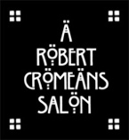
Being a SOLOpreneur at A Robert Cromeans Salon gives you the best of both worlds. You can work side by side with like-minded individuals striving for success, have access to advanced education, both business & creative,
all while having the freedom & full control over your schedule, your guests & your finances.

A Robert Cromeans Salon provides
- Robes, capes for guests
- Towels
- Backbar in the Washhouse (shampoo & conditioner)
- Bowls, bottles, brushes, whisks, scales
- Daily cleaning services (gratuity not included)
- Education
- On-site beauty supply to purchase from
- We use salon scale so you can pull color from the already stocked color bar and pay by the ounce/usage for your chemicals rather than buying full tubes
- Space on robertcromeans.com to feature you as a stylist
- Complimentary Color Bar chair
- 20% retail bonus for Take Home sold
- Key & security code for the salon
- FREE WIFI

FREELANCERS purchase their own
- Scissors, combs, clips, irons, trimmers, clippers, styling brushes
- Foils, gloves, cotton, caps
- Working product for your station
- Color, developer lightener,
- Conditioning treatments
- Brazilian blowout
- Perms
- Extensions
- Business cards &Marketing materials
- POS
- FOR ALL RETAIL PRODUCTS PURCHASED FOR YOUR STATION YOU CAN ENJOY A 50% DISCOUNT OFF OF THE MSRP
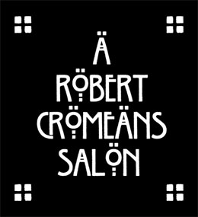

CODE OF CONDUCT AGREEMENT

- BE KIND… to each other and to our guests. Basically EVERYONE!
- Be PROFESSIONAL: in your dress, your conversation, & your actions
- The Washhouse is a little piece of heaven for the guests and the stylist to turn off and relax for a minute. Please honor “no cell phones, no talking”. There are towel warmers for dry and wet hot towels for everyone to use and enjoy.

- SIGN OF A PRO, CLEAN AS YOU GO. Although we have cleaning services daily to help keep the salon looking great, it is up to you to clean up after yourself and be neat while you are working. Clean your station including the bottom of the chair and the mirror. Use stainless steel cleaner for the station, barbicide and chair cleaner for the chair
- COMMUNICATE: Robert, Mary, Danny- you have our emails and phone numbers, we’re here for you!
- Inclusivity & Diversity: We are an INCLUSIVE salon and WELCOME and encourage diversity. We celebrate all hair textures and we absolutely have products for EVERY texture.
- We are a safe space and proud ally of the LGBTQ+ community. We have gender neutral restrooms.
- We encourage our artists to share their pronouns if they are open to it, so we can be sure everyone feels seen, validated and heard

FREELANCE RENTAL RATES

DAILY $100/DAY
$500/week 24/7 access

You need to have
- CA Cosmetology License
- San Diego Business License
- Insurance

